
PORT QUESTIONNAIRE
(to be filled out per ship per call!)

Port: | PUNTA DEL ESTE | Arrival Time: | 07.00
Ship: | ALBATROS | Departure Time: | 09.00
Date: | 30.02.2018 | Public Holiday: | NO
Name & Address of Port |  | Name/No. of expected Berth
PUERTO DE PUNTA DEL ESTE / TERMINAL DE PUNTA DEL ESTE |  | Ship will anchor, approx 20/25’ tender to port area. Distance from downtown area, approx 08 blocks, 10’ walking distance ( either from one Port or from the other )

PORT FACILITIES | N | Bank | N | Post | N | Tourist Info
(Please mark with Y or N) | N | Telephone | N | Internet | Y | Taxi

Telephone Country Code and City Code | Dial out code to Germany: | Postage fee to Germany  (postcard / letter)
+ 598 | 49 | USD 2,50.- (today rate – Mar.2017)
Local Time (GMT +/- hrs) | Languages | Crime Rate
-3 | Spanish
Temperature | Humidity | Recommended Clothing
Average : Max 34 Celsius Degree / Min 18 Celsius Degree | Pretty humid | Average 24C during the day, colder at night.

Nearest Bank/  Exchange Office: | Banking Hrs. |  | Currency |  | € 1,- = | US$ 1,- =
Banks on Gorlero street: approx.. 15-20’ walk from port | BROU (Downtown, at Gorlero Avenue and 25th, and many Exchanges along Gorlero Ave. |  | PESO URUGUAYO  ($U) |  | Today MAR. 2017  1 Euro = $U 32.- | Today MAR. 2017  1 U$S = $U 28,50.-
Accepted Payments | Y | Only local currency |  | Y | Cash in US$ | N | Cash in €
(Please mark with Y or N) | Y | Credit Cards (please specify): Master, Visa, Amex
 | Y | Maestro/Debit Card

 | City Center | Beach | Airport | Main Station
Name of: | Av. Gorlero | Many beaches, along La Mansa or La Brava promenades | Aeropuerto Internacional Laguna del Sauce | Bus Terminal  (Terminal de Buses de Punta del Este.
Distance in km to: | Approx 8 blocks | Depending on where ship will tender : 1 block (Terminal de Cruceros P.del Este or 8 blocks main Port . | Approx 18 km | 5 to 10 blocks walking distance.
Taxi fare to: | USD 10.- | USD 10 to 15 from main Port to Playa Brava or similar) | USD 65.- | USD 12.-

 | Where: | Business/Opening Hours:
Tourist Information | Artigas Square,, approx 10’ walking distance from the port, and Liga de Fomento, Calle 31 & Calle 18, Parada 1 – La Mansa Beach | From 10am to 7 pm
Post Office | Gorlero Avenue between 24 and 17 Streets, downtown. | From 9am to 5pm
Internet Café | Along Gorlero Avenue
Shopping | Along Gorlero Av, 20th Street, and Punta Shopping ( Av Roosevelt and Parada 6 ) | Fm 10am to 10pm
Museums | Casapueblo ( Atelier Carlos Paez Vilarò )  Atchugarry Foundation ( Location : La Barra )  Museo del Mar (Location : La Barra )  Ralli Museum ( Location : Beverly Hills area )  Garcìa Uriburu Museum ( Maldonado ) | Fm 10am to 6pm, closed on Monday.  Daily noon to 6pm  Daily fm 10am to 6pm  Fm 5 to 9pm, Monday closed  Fm 10am to 8pm, Monday closed
Restaurants | Lo de Tere – Rambla Artigas y 21 / Downtown  El Palenque – Av Roosevelt y Parada 6  Soho – Rambla Artigas & Calle 10 / Port area  Il Baretto – Calle 9 & 10 / Downtown  L’Incanto – Av Pedragosa Sierra & La Paloma  La Bourgogne – Av del Mar y Av P.Sierra  Floreal – Av P.Sierra y Eucaliptus | Daily lunch / dinner  Same
Places of interest: | Arboretum Lussich – Camino Lussich, Punta Ballena | Daily 10am to 5pm
 | Art Galleries at La Barra | Daily 10am to 9pm
 | Go for lunch to Jose Ignacio (45 km east) – La Huella Restaurant | Daily lunch / dinner

Shore leave for pax…  (Please mark with Y or N) | Port Agent | …with Landing Card | Port Agent | …with Passport | Same | …no formalities
Visa for German Citizens required  (Please mark with Y or N) | N | …individual visa | N | …group visa upon arrival | Visa fee in € |  | N/A

Typical Souvenirs: | Leather and furs of different national species, silverware and national gems, handicraft leather things ( gauchos tradition ), antiquarians and art galleries
Special Remarks: | PUERTO DE PUNTA DEL ESTE  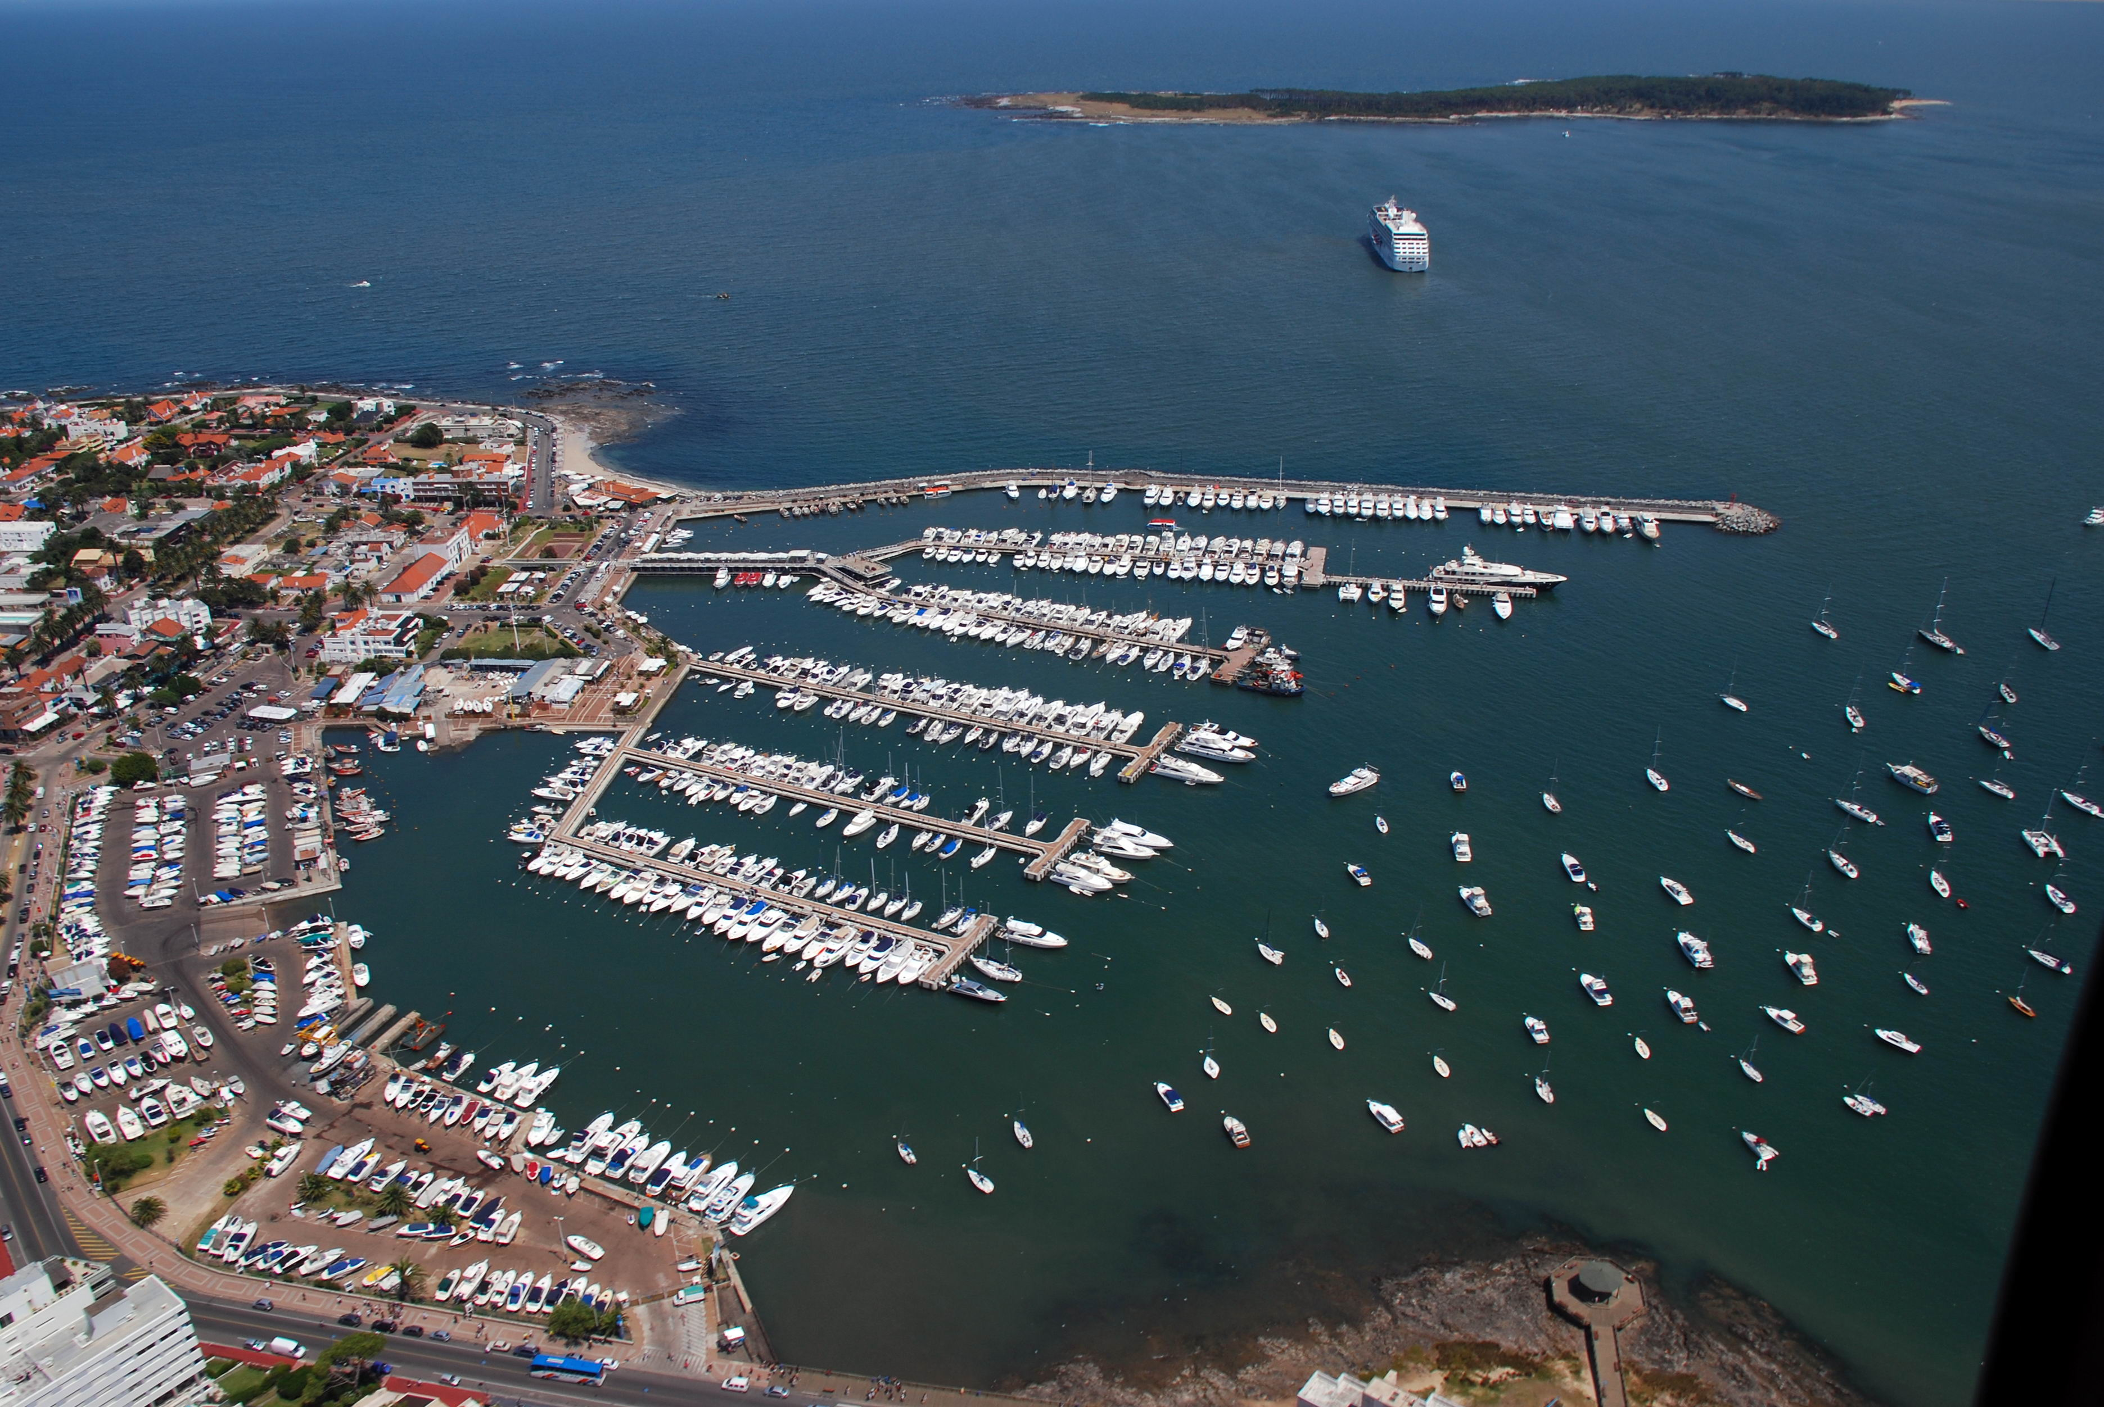  TERMINAL PUNTA DEL ESTE ( MSC Pier )  